A

Major Project Report on

**STABILIZATION OF BLACK COTTON SOIL USING TERRAZYME**

*Submitted for partial fulfilment of the requirements for the award of the degree of*

**BACHELOR OF TECHNOLOGY**

**in**

**CIVIL ENGINEERING**

**by**

|  |  |
| --- | --- |
| **B.SANJANA** | **21K85A0117** |
| **G.DILEEP** | **21K85A0131** |
| **B.PAVAN** | **21K85A0116** |
| **K.JOHN PRASANNA** | **21K85A0134** |

Under the Guidance of

**Mrs. K.CHAITRA**

**ASSISTANT PROFESSOR**

## **DEPARTMENT OF CIVIL ENGINEERING**

|  |  |
| --- | --- |
| **St. MARTIN'S ENGINEERING COLLEGE** |  |
| UGC Autonomous  Affiliated to JNTUH, Approved by AICTE  Accredited by NBA & NAAC A+, ISO 9001-2008 Certified  Dhulapally, Secunderabad-500 100 |  |

**NOVEMBER – 2023**



|  |
| --- |
| **St. MARTIN'S ENGINEERING COLLEGE** |
| UGC Autonomous  Affiliated to JNTUH, Approved by AICTE  NBA& NAAC A+ Accredited  Dhulapally, Secunderabad- 500100  [ww.smec.ac.in](http://www.smec.ac.in/) |

This is to certify that the project entitled **“Stabilization Of Black Cotton Soil Using Terrazyme”** is being submitted by B. Sanjana (21K85A0117), G. Dileep (21K85A0131), B. Pavan (21K85A0116), K. John Prasanna (21K85A0134) in fulfilment of the requirement for the award of degree of **BACHELOR OF TECHNOLOGY IN CIVIL ENGINEERING** is recorded of bonafide work carried out by them. The result embodied in this report have been verified and found satisfactory.

Signature of Guide Signature of HOD

**Mrs. K.CHAITRA Prof. SANDHYA KIRAN J.K**

Assistant Professor Associate Professor and Head of Department

Department of Civil Engineering Department of Civil Engineering

**Internal Examiner External Examiner**

Place:

Date:

**DEPARTMENT OF CIVIL ENGINEERING**

|  |
| --- |
| St. MARTIN'S ENGINEERING COLLEGE |
| UGC Autonomous  Affiliated to JNTUH, Approved by AICTE  NBA& NAAC A+ Accredited  Dhulapally, Secunderabad-500100  [ww.smec.ac.in](http://www.smec.ac.in/) |

**DECLARATION**

We the students of **Bachelor of Technology** in Department of **Civil Engineering,** session: **2021-2024, St. Martin’s Engineering College, Dhulapally, Kompally, Secunderabad** hereby declare that the work presented in this project entitled **‘STABILIZATION OF BLACK COTTON SOIL USING TERRAZYME’** is the outcome of our own bonafide work and it is correct to the best of our knowledge and this work has been undertaken taking care of Engineering Ethics. The result embodied in this project report has not been submitted in any university for award of any degree.

|  |  |
| --- | --- |
| B.SANJANA | 21K85A0117 |
| G.DILEEP | 21K85A0131 |
| B.PAVAN | 21K85A0116 |
| K. JOHN PRASANNA | 21K85A0134 |

|  |  |
| --- | --- |
|  |  |
|  |  |
|  |  |
|  |  |

## **Acknowledgement**

The satisfaction and euphoria that accompanies the successful completion of any task would be incomplete without the mention of the people who made it possible and whose encouragement and guidance have crowded our efforts with success.

First and foremost, we would like to express our deep sense of gratitude and indebtedness to our College Management for their kind support and permission to use the facilities available in the Institute.

We especially would like to express our deep sense of gratitude and indebtedness to **Dr. P. SANTOSH KUMAR PATRA**, Group Director, St. Martin’s Engineering College Dhulapally, for permitting us to undertake this project.

We wish to record our profound gratitude to **Dr. M. SREENIVAS RAO**, Principal, St. Martin’s Engineering College, for his motivation and encouragement.

We are also thankful to **Prof.SANDHYA KIRAN J.K**, Associate Professor, Head of the Department, Civil Engineering, St. Martin’s Engineering College, Dhulapally, Secunderabad, for her support and guidance throughout our project as well as Project Coordinators **Mrs.CH. KALYANI**, Assistant Professor and **Mrs. K. CHAITRA**, Assistant Professor Civil Engineering department for their valuable support.

We would like to express our sincere gratitude and indebtedness to our project supervisor **Mrs. K. CHAITRA**, Assistant Professor, Civil Engineering, St. Martins Engineering College, Dhulapally, for her support and guidance throughout our project.

Finally, we express thanks to all those who have helped us successfully completing this project. Furthermore, we would like to thank our family and friends for their moral support and encouragement. We express thanks to all those who have helped us in successfully completing the project.

|  |  |
| --- | --- |
| B.Sanjana | 21K85A0117 |
| G.Dileep | 21K85A0131 |
| B.Pavan | 21K85A0116 |
| K. John Prasanna | 21K85A0134 |

**ABSTRACT**

Black cotton soil, also known as expansive clay soil or vertisol, is a distinctive type of soil encountered in various regions worldwide. Its unique characteristics, including a high clay content, deep black color, and adhesive consistency, pose significant challenges in construction and engineering projects. The primary challenges associated with black cotton soil are its poor engineering properties, notably low shear strength and high permeability, which make it susceptible to swelling and shrinking with changes in moisture content. These properties can lead to structural instability and damage to foundations and structures built on this type of soil. Terrazyme, an innovative bio-enzyme soil stabilizer, presents a promising solution to address the engineering challenges posed by black cotton soil. Terrazyme operates by introducing enzymes that catalyze the breakdown of some of the clay particles within the soil into smaller silt particles. This transformation results in several beneficial alterations to the soil. The results of this comprehensive study demonstrated that Terrazyme had a significant and positive impact on the properties of black cotton soil. The enzymatic treatment effectively mitigated many of the soil's adverse characteristics, making it more amenable to construction and engineering applications. The findings have promising implications for the construction industry, offering a sustainable and environmentally friendly approach to address soil-related challenges, particularly in regions where black cotton soil is prevalent.

**Key words:** Enzyme, black cotton soil,stabilizer, sustainable.

|  |  |  |
| --- | --- | --- |
| **CONTENTS** |  | |
| **Acknowledgement IV** | |  |
| **Abstract V** | |  |
| **List of Figures Ⅶ** | |  |
|  | |  |
|  |  | |
| **CHAPTER-1 INTRODUCTION** | **01** | |
| 1.1 Expensive soil | **01** | |
| 1.2 Fly ash | **02** | |
| 1.21 Generation and disposal  1.22 classification of fly ash  1.23 utilization of fly ash  1.24 Reaction mechanism of flyash and expansive soil | **03**  **04**  **06**  **08** | |
| 1.3 origin and occurrence of expansive soil  1.31 Nature of expansive soil  1.32 clay mineralogy  1.33 Identification and classification of expansive soil  1.34 methods of reorganization expansive soil  1.35 Problems Associated With The Expansive Soil  1.4 Terrazyme | **08**  **09**  **10**  **12**  **13**  **14**  **15** | |
| 1.5 Objectives | **18** | |
| **CHAPTER-2 LITERATURE SURVEY** | **19** | |
| **CHAPTER-3 METHODOLOGY**  3.1 Objective-1  3.2 Objective-2  3.3 Objective-3 | **31**  **32**  **34**  **36** | |
| **CHAPTER-4 REFERENCES** | **39** | |
|  |  | |

**LIST OF FIGURES**

|  |  |  |
| --- | --- | --- |
| **Figure No.** | **Figure Title** | **Page No.** |
| 1.1 | Expensive soil | 02 |
| 1.2  1.22 | Fly ash  Class-C and class-F Flyash | 03  05 |
| 1.31 | Black cotton soil | 9 |
| 1.32(a) | Kaolinite group | 10 |
| 1.32(b)  1.32(c)  1.4 | Montmorillonite group  Automic structure of illite  Terrazyme | 11  11  16 |
|  |  |  |
|  |  |  |
|  |  |  |
|  |  |  |
|  |  |  |
|  |  |  |
|  |  |  |
|  |  |  |

## **LIST OF TABLE**

|  |  |  |
| --- | --- | --- |
| **TABLE.NO** | **TABLE NAME** | **PAGE NO** |
| 1.22 | Chemical requirement of class C and classD fly ash | 06 |
| 1.23(a) | Production &utilization of fly ashes in different countries | 07 |
| 1.23(b) | Utilization of flyash for different purposes | 08 |
| 1.33 | Swelling potential vs. plasticity index | 12 |

**TABLE OF CHARTS**

|  |  |  |
| --- | --- | --- |
| **TABLE.NO** | **NAME OF CHART** | **PAGE NO** |
| 3.0 | Methodology of project | 31 |
| 3.1 | How terrazyme is reacting with black cotton soil | 32 |
| 3.2 | Test on properties of black cotton soil | 34 |
| 3.3 | Tests conducting on samples | 36 |

**CHAPTER 1**

**INTRODUCTION**

### 1.1 EXPANSIVE SOIL

Expansive soils, which are also called as swell-shrink soil, have the tendency to shrink and swell with variation in moisture content. As a result of this variation in the soil, significant distress occurs in the soil, which is subsequently followed by damage to the overlying structures. During periods of greater moisture, like monsoons, these soils imbibe the water, and swell; subsequently, they become soft and their water holding capacity diminishes. As opposed to this, in drier seasons, like summers, these soils lose the moisture held in them due to evaporation, resulting in their becoming harder. Generally found in semi-arid and arid regions of the globe, these type of soils are regarded as potential natural hazard – if not treated, these can cause extensive damage to the structures built upon them, as well causing loss in human life. Soils whose composition includes presence of montmorillonite, in general, display these kind of properties. Tallied in billions of dollars annually worldwide, these soils have caused extensive damage to civil engineering structures.

Also called as Black Cotton soils or Regur soils, expansive soils in the Indian subcontinent are mainly found over the Deccan trap (Deccan lava tract), which includes Maharashtra, Andhra Pradesh, Gujarat, Madhya Pradesh, and some scattered places in Odisha. These soils are also found in the river valley of Narmada, Tapi, Godavari and Krishna. The depth of black cotton soil is very large in the upper parts of Godavari and Krishna, and the north-western part of Deccan Plateau. Basically, after the chemical decomposition of rocks such as basalt by various decomposing agents, these are the residual soils left behind at the place of such an event. Cooling of volcanic eruption (lava) and weathering another kind of rock – igneous rocks – are also processes of formation of these type of soils. Rich in lime, alumina, magnesia, and iron, these soils lack in nitrogen, phosphorus and organic content.

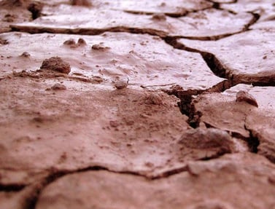

Fig-1.1: Expansive soil

Consisting of high percentage of clay sized particles, the colour of this soil varies from black to chestnut brown. 20% of the total land area, on an average, of this country is roofed by expansive soils. These soils are suitable for dry farming and for the growth of crops like cotton, rice, jowar, wheat, cereal, tobacco, sugarcane, oilseeds, citrus fruits and vegetables; the reason behind it is owed to the moisture retentive capacity of expansive soils, which is high

**1.2 FLY ASH**

A waste material extracted from the gases emanating from coal fired furnaces, generally of a thermal power plant, is called fly ash. One of the chief usages of volcanic ashes in the ancient ages were the use of it as hydraulic cements, and fly ash bears close resemblance to these volcanic ashes. These ashes were believed to be one of the best pozzolans (binding agent) used in and around the globe.

The demand of power supply has exponentially heightened these days due to increasing urbanization and industrialization phenomena. Subsequently, this growth has resulted in the increase in number of power supplying thermal power plants that use coal as a burning fuel to produce electricity. The mineral residue that is left behind after the burning of coal is the fly ash. The Electro Static Precipitator (ESP) of the power plants collect these fly ashes.

Production of fly ash comes with two major concerns – safe disposal and management of fly ash. Because of the possession of complex characteristics of wasters which are generated from the industries, and their hazardous nature, these wastes pose a necessity of being disposed in a safe and effective way, so as to not disturb the ecological system, and not causing any sort of catastrophe to human life and nature. Environmental pollution is imminent unless these industrial wastes are pre-treated before their disposal or storage.

Essentially consisting of alumina, silica and iron, fly ashes are micro-sized particles. Fly ash particles are generally spherical in size, and this property makes it easy for them to blend and flow, to make a suitable concoction. Both amorphous and crystalline nature of minerals are the content of fly ash generated. Its content varies with the change in nature of the coal used for the burning process, but it basically is a non-plastic silt. For waste liners, fly ash is a potential material that can be employed; and in combination with certain minerals (lime and bentonite), fly ash can be used as a barrier material. In present scenario, the generation of this waste material in picture (fly ash) is far more than its current utilization. In other words, we are producing more of fly ash than we can spend.

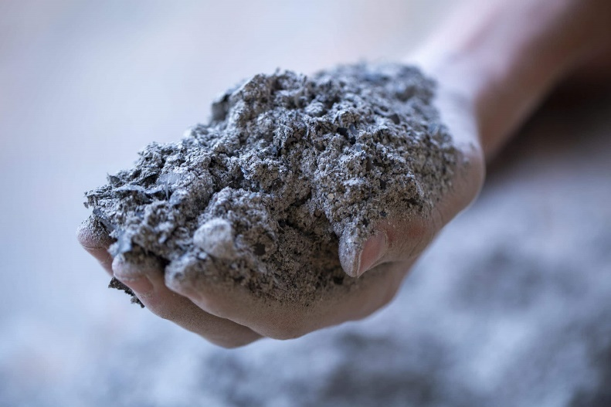

Fig-1.2: Fly ash

### 1.21 Generation and Disposal

Usage of coal in thermal power plants for the generation of steam is a common practice. A method that was proved to be non-energy efficient was used in the past, where coal in form of lumps were expended in the furnaces of the boilers to generate the evaporated content: steam. Thus, in order to optimize the production of energy from coal mass, the thermal power plants began to use pulverized coal mass instead of the aforementioned content. In this process, firstly, this pulverized coal is infused into the combustion chamber, where the instant but efficient burning of fuel happens.

The ash formed as a result of this is called the fly ash, and this fly ash contains molten minerals. The steam around this molten mass, when the coal ash travels with the flue gases, results in the spherical shape of the fly ash particle. Next, the employment of the economizer recovers the heat from the steam gases and fly ash. As a result of this process, the temperature of the fly ash shows a sudden reduction in value. If this temperature fall is rapid, then the resulting structure of the fly ash material is amorphous. However, if the temperature drop during this cooling process is gradual, then the fly ash assumes a more crystalline in nature. This shows the implementation of the economizer, and how it improves the reactivity process. In the process where fly ash is not subjected to the economizer, it forms a 4.3% soluble matter, and its pozzolanic activity index clocks to 94%. Whereas, during the process where the fly ash exposed to the economizer, its pozzolanic activity clocks to 103% and it forms a 8.8% soluble matter. In conclusion, fly ashes are separated from the flue gases by a mechanical dust collector, which is commonly referred to as Electro Static Precipitator (ESP), or scrubbers. Free of fly ashes, the rest of the flue gases are liberated into the atmosphere via the chimney.

With about 90%-98%, the efficiency of ESPs for the separation of finer and lighter fly ash particles is high. In general, the fly ash consists of four to six hoppers, named as field. The fineness of the fly ash particles collected are thus proportional to the number of fields available.

Therefore, the fly ashes that are collected from the first hopper have a specific surface area of about 2800 2/gm, whereas the fly ash collected from the last hopper exhibit a greater specific surface area, that is, 8200 2/gm. With the scorching of pulverized coal, the resulting ash content forming during the process are either collected as fly ash or bottom ash. 80% of coal ashes that are removed from the flue gases are recovered as fly ash, whereas the remaining 20%, that are generally coarser in size, are collected at the bottom of the furnace as bottom ash. Either in dry form, or its collection from a water-filled hopper, bottom ash is taken from the bottom of the furnace. When there is a sufficient amount of bottom ash in the water- filled hopper, beyond which its disposal becomes imminent before moving on to the next process, the transference can occur by water jets or water sluice to a disposal pond which. This disposed waste is then called as pond ash. The below figure gives an idea of disposal of coal ash in a thermal power plant where coal is a fuel.

### 1.22 Classification of fly ash

The extracted ash from the flue gases via an Electro Static Precipitator, after the process of pulverization, is called fly ash. It is the finest of particles among bottom ash, pond ash and fly ash. With some unburned carbon, the fly ash chiefly consists of non-combustible particulate matter. These generally consists of silt-sized particles. On the basis of a lime reactivity test, fly ashes have been classified into four different types, as given:

* + - * Cementitious fly ash
      * Cementitious and pozzolanic fly ash
      * Pozzolanic fly ash
      * Non-pozzolanic fly ash

With free lime content and negligible reactive silica, this fly ash is called as cementitious. As opposed to this, with negligible free lime content, and chiefly reactive silica, this fly ash is called pozzolanic fly ash. Both reactive silica and free lime are predominant in cementitious and pozzolanic fly ash.Neither free lime, nor reactive silica are present in non-pozzolanic fly ash. The distinguishable difference between cementitious fly ash and pozzolanic fly ash is that

the cementitious fly ash hardens when it comes in connexion with water, whereas the pozzolanic fly ash hardens only after the activated lime reacts with water. Cementitious & Pozzolanic Fly Ash and Pozzolanic Fly Ash are the types that are found widely.

Based on the chemical composition of fly ash, fly ash has been categorized into two categories, as given:

Class C fly ash

Class F fly ash

Burning of sub-bituminous type of coal and lignite, which contains more than 20% Calcium Oxide, gives the Class C fly ash. By ignition of anthracite and bituminous type of coal, Class F fly ash comes into the picture. This fly ash contains less than 20% Calcium Oxide.

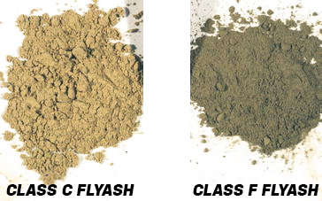

Fig-1.22: class-C & class-F Fly ash

The chemical configuration of Class C and Class F fly ashes are as follows, in the given table:

**Table 1.22 Chemical requirement of class C and class F fly ashes (data source: ASTM C618-94a)**

|  |  |  |  |
| --- | --- | --- | --- |
| **Particulars** | | **Fly ash** | |
| **Class F** | **Class C** |
| **Fly ash**+ | **% minimum** | 70.0 | 50.0 |
| **Fly ash** | **% maximum** | 5.0 | 5.0 |
| **Fly ash** | **% maximum** | 3.0 | 3.0 |
| **Fly ash** | **% maximum** | 6.0 | 6.0 |

**1.23 Utilization of Fly Ash**

The utilization of fly ash can be largely grouped into following three classes:

* The Low Value Utilizations, which includes back filling, structural fills, roadconstruction, soil stabilization, embankment & dam construction, ash dykes, etc.
* The Medium Value Utilizations, which includes grouting, cellular cement, pozzolana cement, bricks/blocks, soil amendment agents, prefabricated buildingblocks, fly ash concrete, weight aggregate, etc.
* The High Value Utilizations, which includes, fly ash paints, ceramic industry, extraction of magnetite, distempers, metal recovery, acid refractorybricks, floor andwall tiles, etc.
* After these, there is still a large wastage of fly ash material observed; however, this has led to evolution of large number of technologies for the management of fly ashes. Thanksto this, the utilization of fly ash has increased to 73 MT by the year 2012.saw a wide acceptance of fly ash as a product that can be used in various purposes.
* Presently, the production of fly ashes in India is about 130 MT/year, and this is expected to rise by 400 MT by the year 2016-2017, as stated by 2nd annual international summit for fly ash utilization 2012, scheduled on 17th-18th of January, 2013 at NDCC II convention centre, NDMC Complex, New Delhi, India.
* Therefore, the fly ashes that are collected from the first hopper have a specific surface area of about 2800 2/gm, whereas the fly ash collected from the last hopper exhibit a greater specific surface area, that is, 8200 2/gm.
* With the scorching of pulverized coal, the resulting ash content forming during the process are either collected as fly ash or bottom ash. 80% of coal ashes that are removed from the flue gases are recovered as fly ash, whereas the remaining 20%, that are generally coarser in size, are collected at the bottom of the furnace as bottom ash. Either in dry form, or its collection from a water-filled hopper, bottom ash is takenfrom the bottom of the furnace.
* When there is a sufficient amount of bottom ash in the water- filled hopper, beyond which its disposal becomes imminent before moving on to the next process, the transference can occur by water jets or water sluice to a disposal pond which. This disposed waste is then called as pond ash. The below figure gives an idea of disposal of coal ash in a thermal power plant where coal is a fuel.

Table 1.23(a) Production & Utilization of fly ashes in different countries

|  |  |  |
| --- | --- | --- |
| **Country** | **Annual Ash Production (MT)** | **Ash Utilization in %** |
| **India** | 131 | 56 |
| **China** | 100 | 45 |
| **Germany** | 40 | 85 |
| **Australia** | 10 | 85 |
| **France** | 3 | 85 |
| **Italy** | 2 | 100 |
| **USA** | 75 | 65 |
| **UK** | 15 | 50 |
| **Canada** | 6 | 75 |
| **Denmark** | 2 | 100 |
| **Netherland** | 2 | 100 |

As a palpable conclusion from the previous table, the fly ash utilization in India is about 56%, as in 2010-2012, which leads to the fact that the rest 44% are waste material, dumped/disposed chiefly out in the open, and considering the adverse effect of this waste material on our environment, it is of necessity to utilize all of the fly ash produced by coal based thermal power plants. An increase of efforts have to be observed if we were to achieve a 100% utilization of this waste product. If we were to execute the usage of fly ash properly in low value applications, more than 60% utilization of fly ash we currently produce can be seen. In present scenario, India is 65%-70% dependent on production of energy by coal based thermal power plants, which tallies the fly ash production of the country, as stated earlier, up to 130 MT/year.

Table 1.23(b) Utilization of fly ash for different purposes. Data source: Ministry of Environment & Forests

|  |  |
| --- | --- |
| **Mode of Fly ash applications** | **% Utilization** |
| **Dykes** | 35 |
| **Cement** | 30 |
| **Land development** | 15 |
| **Building** | 15 |
| **Others** | 5 |

**1.24 Reaction mechanism of Fly ash and expansive soil**

By itself, fly ash has little cementitious value, however, this changes in presence of moisture, with which it reacts chemically, and forms cementitious compounds. These compounds attributes to the improvement of compressibility and strength characteristics of a soil. Both classes of Fly ash (C & F) are pozzolans i.e. they contain siliceous and aluminous materials. Fly ash can thus produce an assortment of divalent and trivalent cations (2+, 3+, 3+ etc.) under conditions that areionized in nature, which in return can encourage flocculation of dispersed clay particles.

Expansive soils can thus be theoretically stabilized in an effective manner by cationic exchange with fly ash.

### 1.3 ORIGIN AND OCCURRENCE OF EXPANSIVE SOIL

Clay mineral is the key element which divulges the swelling characteristics to any ordinary non- swelling/non-shrinking soil. Montmorillonite, out of several types of clay minerals has the maximum amount of swelling potential. In-situ formation of chief clay minerals occurs under alkaline conditions, or sub-aqueous decomposition of blast rocks can be seen the origin of such soil – expansive soil. These type of soil can also be formed due to weathering under alkaline environments, and under adequate supply of magnesium or ferric or ferrous oxides. Given there‟s a good availability of alumina and silica, the formation of Montmorillonite is favoured.

Therefore, the fly ashes that are collected from the first hopper have a specific surface area of about 2800 2/gm, whereas the fly ash collected from the last hopper exhibit a greater specific surface area, that is, 8200 2/gm.

With the scorching of pulverized coal, the resulting ash content forming during the process are either collected as fly ash or bottom ash. 80% of coal ashes that are removed from the flue gases are recovered as fly ash, whereas the remaining 20%, that are generally coarser in size, are collected.

**1.31 NATURE OF EXPANSIVE SOIL**

Swelling in clays can be sub-categorized into two distinctive types, namely:

* Elastic rebound in the compressed soil mass due to reduction in compressive force.
* Imbibing of water resulting in expansion of water-sensitive clays.Swelling clays are the clays that exhibit latter type of swelling, where the clay minerals with largely inflating lattice are present. One of the fundamental characteristics of clayey soil is that they display little cohesion and strength when wet, but they become hard when devoid of water. However, all of them do not swell due to wetting action. Decrease in ultimate bearing capacity at saturation, and large differential settlement due to this occurs. Thus, clayey soils exhibit foundation problems.

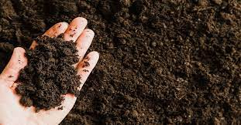

Fig-1.31: Black cotton soil

**1.32 Clay Mineralogy**

On the basis of their crystalline arrangement, clay minerals can be categorized into three general groups, namely:

1. Kaolinite group
2. Montmorillonite group
3. Illite group
4. **Kaolinite group:**

A clay mineral which has a chemical composition 2 205( )4 is called Kaolinite. This type of clay mineral has a layered silicate, with linkage to one octahedral sheet of alumina through oxygen atoms. China clay or Kaolin is the name given to rocks that are rich in this mineral. A thickness of 7Å is exhibited by the stacked layers of kaolinite; as a result of this, kaolin group of minerals are seen to be the most stable, which is also because of the fact that water cannot enter between the sheets to inflate that unit cell.

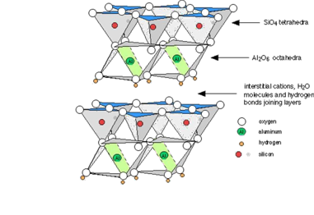

Fig-1.32 (a): Kaolinite group

**Montmorillonite group**

Two silica tetrahedral sheets combined with a central alumina octahedral sheet comprise the structural arrangement of Montmorillonite. The bond between crystal links is weak here. Thus, the soil containing higher percentage of Montmorillonite minerals demonstrate high shrinkage and swelling characteristics, depending on the nature of exchangeable cation present.. Atoms which are common to both silica and gibbsite layers never participate in the process of swelling.

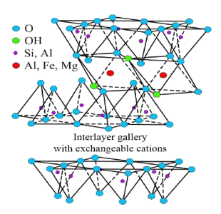

Fig-1.32(b):Montmorillonite group

### Illite group

As far as structural arrangement is concerned, Illite minerals fall between Montmorillonite and Kaolinite group. As in case of Montmorillonite unit structure, two silica tetrahedral sheets combined with a central alumina octahedral sheet comprise the structural arrangement of Illite.

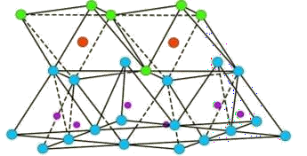

Fig-1.32(c): Atomic structure of Illite

The space between this T-O-T sequence of layers is occupied by poorly hydrated potassium cations which are responsible for the absence of swelling. Structurally, illite is quite similar to [muscovite](https://en.wikipedia.org/wiki/Muscovite) with slightly more [silicon,](https://en.wikipedia.org/wiki/Silicon) [magnesium,](https://en.wikipedia.org/wiki/Magnesium) [iron,](https://en.wikipedia.org/wiki/Iron) and water and slightly less tetrahedral [aluminium](https://en.wikipedia.org/wiki/Aluminium) and interlayer [potassium.](https://en.wikipedia.org/wiki/Potassium)

The chemical formula is given as (K,H3O)(Al,Mg,Fe)2(Si,Al)4O10[(OH)2·(H2O)][,[3]](https://en.wikipedia.org/wiki/Illite#cite_note-Webmin-3) but there is considerable ion (isomorphic) substitution. It occurs as aggregates of small [monoclinic](https://en.wikipedia.org/wiki/Monoclinic) grey to white crystals. Due to the small size, positive identification usually requires [x-ray diffraction](https://en.wikipedia.org/wiki/X-ray_diffraction) or SEM-EDS ([automated mineralogy](https://en.wikipedia.org/wiki/Automated_mineralogy)) analysis. Illite occurs as an altered product of muscovite and [feldspar](https://en.wikipedia.org/wiki/Feldspar) in [weathering](https://en.wikipedia.org/wiki/Weathering) and [hydrothermal](https://en.wikipedia.org/wiki/Hydrothermal) environments; it may be a component of [sericite.](https://en.wikipedia.org/wiki/Sericite)

**1.33 IDENTIFICATION AND CLASSIFICATION OF EXPANSIVE SOILS**

Some laboratory tests are available for the identification purposes of swelling soils. By differential thermal analysis, Microscopic examination, and X-ray diffraction. The presence of Montmorillonite in clay minerals allows the judgement of the expansiveness of the soil. This aspect is however very technical in nature. A simple aspect, as opposed to the aforementioned methods, is the free-swell test, that‟s done in the laboratory. This test is conducted by adding 10 gm of dry soil, passing through a 425 μ sieve into two separate 100 cc graduated jar – one filled with water, and the other with kerosene. Swelling occurs in the jar containing water.

The swelled volume of the soil is then noted (after 24 hours period), and subsequently, the free swell index values, in percentage, are calculated. IS: 2720-II was followed for free swell index test.

Free swell value [ ] (in %age) = ( − ) 100

Good grade, high swelling, commercial Bentonite has been reported to have free swell values varying from 1200% to 2000%. In general, the swelling potential of a soil is related to plasticity index. With corresponding range of plasticity index, various degrees of swelling capacities are as indicated through the following table:

Table -1.33: Swelling potential vs. Plasticity Index

|  |  |
| --- | --- |
| **Swelling potential** | **Plasticity Index** |
| Low | 0-15 |
| Medium | 15-24 |
| High | 24-46 |
| Very High | >46 |

Several factors participate in deciding whether or not a soil with high swelling potential exhibit swelling characteristics. One of these factors, that occupy greatest importance, is the difference between soil moisture content at the time of construction, and final (equilibrium) moisture content finally achieved under various conditions allied with the complicated structure. The soil has a high swelling capacity if the equilibrium moisture content is higher than the soil moisture content. Large swelling pressure may develop as a result of the upheaving of the soil or structure, causing swelling.

### 1.34 Methods of recognizing expansive soils

Grouped into three categories, following are the methods of recognizing expansive soils:

* Mineralogical identification
* Indirect methods, such as soil suction, activity and index properties
* Direct measurement.

Impractical and uneconomical in practice, methods of mineralogical identification still hold importance in exploring basic properties of clay minerals. Direct measurement, out of the remaining two categories, offers the most useful data.

By their shattered or fissured condition, or obvious structural damage to existing buildings caused by such soils, potentially expansive soils are usually identified in the field. To classify expansive soil, potential swell, or potential expansion, or the degree of expansion is a favoured term used; from this, geotechnical engineers establish how good or bad the expansive soils are.

**CAUSES OF SWELLING**

There are different theories, but the mechanism of swelling is still unclear. No conclusion to the mechanism have been reached. Soil consisting high percentage of clay or colloid, with Montmorillonite mineral present as the chief mineral is one of the most universally accepted reasons for the swelling of soils.

**SWELL PRESSURES**

The pressure exerted by expansive soil when they swell, owing to their contact with water, is called swell pressure. The estimation of this swell pressure and likely becomes a very important task for designing a structure on such soils, or building the core of a dam, or constructing a road embankment, or taking a canal through such soils.

**FACTORS AFFECTING SWELLING**

Initial moisture content, or the molding water in case of a re-molded sample is the most influencing factor. “The behaviour of re-molded clays is much as undisturbed clays”, as per Holts‟ and Gibbs‟ findings. For a given dry density, the value of initial water content will be a key factor in determining the water affinity of a given sample, as well as its swell pressure. A minimum moisture content ( ) required by a clay for swelling to begin beneath a pre-paved sub- grade is given by:

Where, 1 = liquid limit

(%) = 0.2 1 + g

The factors that affect the swelling aspect of a soil largely depend on the soil‟s environmental conditions. With the intake of water, swelling is more in a soil element which is close to the surface, but if below the surface, the same soil exhibit negligible swelling because the overburden pressure neutralizes the developing swelling pressure of the dry soil.

Generally responsible for swelling are the following factors:

* Location of the soil sample from the ground surface
* Thickness, as well as shape of the sample
* Change in volume
* Temperature
* Nature of pore fluid
* Time
* Stress history
* Unit weight of the sample taken, etc.

**1.35 PROBLEMS ASSOCIATED WITH THE EXPANSIVE SOIL**

Generation of problems for all kinds of construction over expansive soils is common, leading us to believe that such types of soil are not suitable for these purposes. However, given the placement of these kinds of soil over the country, it leaves engineers no other choice but to develop different structures on the soil, well aware of the risk. These structures chiefly are a part of irrigation projects. Buildings, and other kinds of structures constructed over these soils are subjected to differential deflections. These deflections cause distressing, and in turn leads to damage of the structure.

Moreover, the reduction in moisture content due to the evaporation of water in soil causes shrinkage, and heaving of soil occurs when there is a disproportionate increase in moisture content. The level of ground water table also has a significant impact on the moisture content of these soils, which in return affect the shrinkage-swelling cycles. In seasons which are dry in nature, the surface of clayey soil shrinks, however, little evaporation is there on the clayey soil on which the building stands. This causes differential settlement at plinth level, posing danger to the structure.

If the construction of a building on such type of soil is done in its dry season, the base of the structure‟s foundation would experience swelling pressures when the partially saturated soil underneath starts imbibing water in the wet season, developing swelling pressures. When the pressure imposed by the structure on the foundation is less than the swelling pressure developed, upliftment of such a structure occurs, which would lead to formation of cracks. The imposed bearing pressure if the building is constructed in the wet season should be within the permissible limits of bearing pressure for the soil. A better practice is to construct a building during dryseason, and completing it before the onset of wet seasons.

One of the methods of treatment of expansive soil to make them fit for the construction purposes is called stabilization. According to Petry (2002), assortment of stabilizers can be grouped into:

a) By-product stabilizers (Quarry dust, Fly ash, Slag, Phosphor-gypsum, etc.)

b) Traditional stabilizers (Cement, Lime, etc.)

c) Non-traditional stabilizers (Sulfonated oils, Potassium compounds, Polymer, Enzymes,etc.)

Lots of geo-environmental problems are a result of industrial by-products whose disposal as fills in disposal sites adjacent to the industries demand large chunks of land, which can otherwise be utilized for construction, growing of vegetation, etc. purposes. Various attempts by different researchers and organizations have been made to utilize these by-products. Stabilization of expansive soil is one of the ways of fulfilling such a thing.

**1.4 TERRAZYME**

TerraZyme is an environmentally friendly soil stabiliser used in the construction of road infrastructure. The product provides a tool for engineers to reduce the construction costs, whilst increasing the overall quality of road structures. TerraZyme is easy to use, not harmful to the environment or its users and guarantees a better and longer lasting road that has been accepted and appreciated WORLD WIDE.The use of TerraZyme in the construction of base and sub-base structures removes the need for the use of a sand/gravel mix, soling or water bound macadam in the construction of road structures. The base and sub-base constructed with TerraZyme are built up immediately from the sub-grade level. Between the sub-grade and the asphalt or concrete layers, TerraZyme constructed structures have a much greater flexural strength and a higher CBR % than the conventional structures.

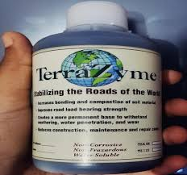

Fig-1.4 : Terrazyme

**A COST-EFFICIENT & ECO FRIENDLY ALTERNATE FOR GSB AND WMM ROADS**

With changing pace and time, considering the climatic and environmental impact, we have been continuously innovating. This is our mission behind introducing and promoting **TerraZyme, an eco-friendly product**. We at Manibhadra Earthmovers in association with Avijeet Agencies (P) Ltd (distributors of TerraZyme in India for past 19 years) have taken up exclusive rights for Western India Region for TerraZyme. This product is manufactured by Nature Plus Inc, USA. The vast experience of 30 years in road work and their expertise has lead has lead to this synergy of interests in promoting TerraZyme.

TerraZyme is an excellent replacement for GSB and WMM. The use of TerraZyme leads to a saving upto10% to 30% - per Sq.mt in road construction. TerraZyme is a biodegradable product made from plant and vegetable extracts. It helps in the workability of soil by improving the engineering properties of the soil like CBR value, ITS, Density. It also helps in reducing OMC, plasticity index of soil and its permeability.

**ADVANTAGES**

The main feature of TerraZyme is the cost saving aspect. TerraZyme saves cost upto 30% in comparison to conventional system of road construction and maintenance cost of roads is reduced by 50%

* Cuts construction cost by 10% - 30%
* Higher CBR value / higher road strength : TerraZyme base structures have a higher CBR value
* Lowers the maintenance cost by 30 - 50%
* Saves construction time by 50%
* The life-cycle of TerraZyme treated roads increase by 200–300%
* Pavement thickness can be reduced by up to 30 %, being semi rigid in nature
* Environment friendly and bio-degradable product

**USES OF TERRAZYME**

TerraZyme can be used anywhere where GSB and WMM are used in construction as it replaces them.

* Highways
* All weather rural roads
* Internal roads in townships
* Service roads
* Factory roads
* Parking Lots and Yard area
* Sealing of ponds, landfills
* Temporary access roads
* Subgrade improvements
* Floor bases
* Road shoulders
* Construction roads

**1.5 OBJECTIVES:**

* To evaluate the effect of Terrazyme on the basic properties of soil.
* To determine the geotechnical properties of black cotton soil
* To determine the effects of adding enzyme to black cotton soil on its properties like consistency limits, standard proctor test, Free swell index, California bearing ratio test and unconfined compressive strength of the soil.

**CHAPTER 2**

**LITERATURE SURVEY**

**INTRODUCTION:**

Stabilization of black cotton soil has been a significant concern in geotechnical engineering due to its expansive nature and susceptibility to swelling and shrinkage. Black cotton soil, also known as expansive clay soil, poses challenges for construction projects, as its volume changes with variations in moisture content, leading to structural instability. Various methods have been explored to mitigate these challenges, and one such approach gaining attention is the use of enzymes like Teerazyme. Teerazyme, a proprietary enzyme blend, has shown promise in stabilizing black cotton soil by modifying its physicochemical properties. The enzyme acts by breaking down certain organic compounds within the soil, affecting its plasticity and improving its overall stability. This literature review aims to critically analyze existing research on the use of Teerazyme for stabilizing black cotton soil, assessing its effectiveness, mechanisms of action, and the implications for geotechnical engineering.

**1. Kajal Sinha Supriya Waghmare, Anushree Borkar, Kajal Pachdhare:** **STABILISATION OF BLACK COTTON SOIL USING BIO-ENZYME [2022]**

A large part of central India and south India are covered with black cotton soil such soil need to improved. The conventional methods are time consuming are not economically feasible. Hence there is need to discover the other possible ways to satisfy the performance as well as economical criteria. The stabilization soil with bio-enzymes is a revolutionary technique which is environment friendly, cost effective and convenient to use. There are many bio enzymes available for soil stabilization such as DZ-1X, Renolith, perma-zyme, terra-zyme and fujibeton. Bioenzyme improves CBR value of soil. Increases strength of soil and decreases free swell index and cracks formation. It is economical and also reduces the pavement thickness. Bioenzymes are largely use for stabilization of soil of roads. The present study deals with the effect of DZ-1X, a bioenzyme on shear strength and CBR value of expansive soil. Their efficiency depends upon the amount of dose type of soil available and field conditions. The use of bio-enzyme in soil stabilization is not very popular due to lack of awareness between engineers and non-availability of standardized data. Duration of treatment of soil with Bio-enzyme played a vital role in improvement of strength and soil treated with bio-enzyme for 7 days gives higher strength. The cost of construction project can be reduced considerably with use of bio-enzyme.

2) With increase in percentage of Dz-1X and days of curing shear strength of the soil increased from 10.8 kPa to 49.05 kPa, results are tabulated for 4 days of curing period. Percentage increase is 354.1%.

3) The use of bio-enzyme in pavement construction is proven to be very economical as compared to other traditional soil stabilization methods.

4) With increase in percentage of Dz-1X the un-soaked CBR value was increased from 3.93 to 8.03. Percentage increase is 104.32.

5) With increase in soaking period CBR values are increased when compared with untreated soaked soil samples.

6) Tri-Axial results showed, with increase in percentage of DZ-1X shear strength of the soil increased from 6.40 kPa to 35.32 kPa, percentage increase is 451.87.

7) Tri-Axial results showed with increase in percentage of Dz-1X , cohesion of the soil increased.

**2. Priya.K.Figueredo, Swapnil. D. Pawar, Shwetha Bhogavkar: STABILIZATION OF BLACK COTTON SOIL USING BIO ENZYMES & GEOSYNTHETHIC MATERIAL (BAMBOO FIBRES) [2022]**

In this work, the activity of BioEnzyme-stabilized soil was investigated. Based on the experiments carried out in the laboratory, the following conclusions were drawn: The clay content is of great importance in the variation of consistency limits. It is observed that the liquid limit decreases from 61. 0% to 56. 9% of while the plastic limit of decreases from 3 .0% to 31.70% of with dosage . Enzyme -treated changes are marginal. soil due to MDD 1. 86 gm/cm3 , 1.633 gm/cm3 where the decrease in OMC is found to be 23.00-20. 0%. The reduction is due to the effective cat ion exchange process, which usually takes longer in the absence of such stabilizers. The UCS value increases to 3.53 KN/m2 ,8.86 KN/m2 when compared to the original soil after a -week curing period. This is due to the reaction of enzyme with clay , resulting in a cementing effect. The reaction time is important because the strength at after weeks (150.99% increase from the original soil) is greater than at after 1 week (88.10% from the original soil). Soaked CBR values of treated were observed to increase with longer treatment periods due to enzyme treated soil improving density reducing void ratios. Initially, the soaked CBR value of the native soil was 1.19%, but as stabilized after weeks of curing, the soaked CBR value of was 5.80%, which represents an increase of 387% compared to the original so. Designing a foundation on black cotton soil (swelling soil) has always been a difficult task for engineers, as a structure resting on black cotton soil will crack without warning. Black cotton land is found in our country in M.P., Karnataka, Maharashtra and Andhra Pradesh. The proportion of soil varies depending on its constituents, i.e. water content, density, bulk density, friction angle, shear strength, etc. The properties of black cotton soil can be modified by soil stabilization by modifying the soil stabilization with additives or by mechanical means. With this project, an attempt was made to stabilize the soil with lime. Experiments were performed with % and 6% lime content. The test work is based on different percentages of soil lime in liquid limit, plastic limit, O.M.C., M.D.D, soil bulk density and dry density tests, C.B.R. test, analysis of grain size and swelling pressure. The aim is to improve the technical properties of the black cotton soil so that the structure built on this soil can effectively withstand the applied loads. It was found that the technical properties of the black cotton soil improved significantly with the addition of lime.

**3. N Mall, K Venkatesh: SOIL STABILIZATION USING BIO ENZYME [2022]**

Soil stabilization is a successful method for boosting both the performance of a pavement system and the properties of the soil. India, a developing country, performs in-depth research on soil stabilization to improve the soil's qualities by using a variety of waste products and bio enzymes. Nowadays, there are various types of bio enzymes. Some of them include DZ-1X (Name of a of Bio enzyme), Terrazyme, Permazyme, and Renolith. The majority of papers use soil, rich in clay, to stabilize the soil with bio enzyme. In the laboratory, tests including sieve analysis, hydrometer method, Atterberg limits, Standard proctor test, California bearing ratio test, and Unconfined compression test are performed. These enzymes have shown to be quite efficient and economically priced. Using bio enzymes has the added benefit of being environmentally friendly.

**4. Rohit Sahu, Krishna Thakur, Pankaj Singh, Sonu Kumar, Rohit Kumar Jatav: AN INVESTIGATIONAL EVALUATION ON SOIL STABILIZATION BY USING BIO-ENZYMES [2022]**

The conventional methods are time consuming and are not economically feasible. Hence there is a need to find the other possible ways to satisfy the performance as well as economical criteria. These enzymes have been demonstrated to be very effective and economical. Another advantage of the bio enzyme is that these are environment friendly. The efficiency of bio enzyme depends upon the amount of quantity, type of soil and curing time span. In our country vast areas consist of black cotton soils. As the conventional soil stabilizers like gravel, sand and others are exhausting and becoming costly day by day at a very rapid pace, it becomes necessary to look towards for alternative eco-friendly stabilizers as their substitute. Recently many Bioenzymes have emerged as cost effective stabilizers for soil stabilization. Some such type of bio-enzyme, like Terazyme, bagasse ash, lime etc. has been used in the present work. Recently many Bio-enzymes have emerged as value influential stabilizers for soil stabilization. One such Bio-enzyme, Terrazyme, has been used withinside the gift paintings to take a look at its impact at the Unconfined Compressive electricity of the Black Cotton soil. It has been located that Terrazyme dealt with Black Cotton soil suggests vast boom in Unconfined Compressive electricity with longer curing period The following conclusions can be drawn from the results of the investigation carried out within the scope of the study. The chemical analysis of bagasse ash indicated that the main element were silica (66.23%), potassium (6.44%) iron (3.09%), their combined percent composition is 75.76 % which is above 70 % specified by (ASTM 2012) standards for pozzolanic reaction. The plasticity index reduced with increased in content of bagasse ash and lime but the increment for bagasse ash was insignificant compare with the set standard by Road design manual part III. Bagasse ash alone cannot be used for expansive Black Cotton soil stabilization. California bearing ratio increased for lime samples but reduced for bagasse ash samples and this was attributed to negligible amount of calcium present in bagasse ash. Similarly bagasse ash has negative impact on the strength of expansive Black Cotton soil hence cannot be used as standalone stabilizer. When bagasse ash partially replaced lime, plasticity index reduced and California bearing ratio increased as the ratio varies. At the ratio of 4:1 (lime:ash) the results obtained conformed with the standard set Road design manual part III of CBR 36 %, PI 20% , linear shrinkage of 9.0 and negligible swelling thus can be used for expansive Black Cotton stabilization.

**5. Ramanjaneyulu, N. Darga Kumar, C. Lavanya: EFFECT OF MARBLE DUST AND TERRAZYME ON UCS AND CBR CHARACTERISTICS OF CLAY SOIL [2022]**

The maximum dry density (MDD) for soil treated with 0.25ml/kg Terrazyme and 15% marble dust is increased about 12% than untreated soil and the Optimum moisture content (OMC) remains unchanged. Liquid limit of soil treated with 0.25ml/kg Terrazyme and 15% marble dust is reduced 5% and plastic limit reduced 11% compared to untreated soil. The unconfined compressive strength (UCS) of untreated clay is 245 kPa which is increased about 44%, 111%, and 103% by adding the Terrazyme dosages of 0.125ml/kg, 0.25ml/kg and 0.5ml/kg and cured for 28days. From the SEM images of clay soil and clay soil admixed with Terrazyme, it can be observed that the Terrazyme which is added to clay soil acts as a catalyst in accelerating the cementation. Calcium-Silicate-Hydrate is formed from the reaction of Marble dust with untreated soil. CBR test results shows the increase in percentage of CBR is more for dosage of Terrazyme 0.25ml/kg compared to 0.125ml/kg and 0.5m/kg. CBR of untreated clay at 5mm penetration is 4%, whereas the CBR values of clay soil treated with 0.125 ml/kg, 0.25ml/kg and 0.5 ml/kg and cured for 28 days showed 13.13%, 21.46%, and 21.00% improvement as compared to the untreated soil. It is witnessed that mixing of 0.25ml/kg of Terrazyme along with 15% marble dust provides improved strength and CBR of the soil subgrade**.** Bio-enzyme is an eco-friendly stabilizing agent, which can be derived from plants and microorganisms. Marble dust, on the other hand, is a by-product of the marble industry. This paper focusses the utilization of marble dust in clay soil stabilization and also the studies carried out to understand the effect of Terrazyme on UCS and CBR of clay soil. Unconfined compression stress (UCS) tests and California Bearing Ratio (CBR) tests were conducted on mixes of clay soil + Terrazyme+ marble dust to bring out the efficacy of the marble dust and Terrazyme on UCS and CBR values of clay soil. The dosages of Terrazyme used in the study are 0.125ml, 0.25ml and 0.5ml per kg of dry soil. The marble dust proportion of 15% is considered constant in all the tests. The results revealed that the UCS of treated clay has increased with increased Terrazyme dosage for all mix proportions and further noticed that the samples subjected to 7 and 14 days curing period resulted in high improvement in UCS of clay soil. This improvement is about 69% and 101% respectively for both 7 days and 14 days cured mixes as compared to the untreated soil. At 0.25 ml/kg of Terrazyme, the UCS and CBR of 28 days cured mix showed better results than the soil treated with 0.5 ml/kg. The microstructural analysis, such as XRD and SEM, showed the formation of C-S-H gel, which resulted in improvement of soil strength and CBR. Overall, use of 0.25ml/kg Terrazyme and 15% marble dust results in higher CBR and UCS for soil and also it eases the utilization of waste marble dust in the construction industry as stabilizing material.

**6. S Shivhare, H Mohanan: A REVIEW ON SUBGRADE SOIL STABILIZATION USING BIO ENZYMES [2020]**

Roads carry a majority of the transport of any nation and thus should be strong, durable, and cost-effective. One of the most important components of a pavement structure is the subgrade, which is the bottom layer. Ultimately, the subgrade bears all the load of the transport, and hence, this layer should be stabilized, compacted, and have sufficient strength. Here comes the importance of soil stabilization. Traditional stabilizers were effective in imparting the required strength and stability to the amended soil mass; they were not cost-effective and often adversely impacted the environment. As a result of these drawbacks, research is being extensively carried out to develop new stabilizers, which can outperform the traditional ones and, at the same time, can be environmentally friendly and economic as well. One such category of non-traditional stabilizers is bio enzymes, which are extracted from vegetables, plants, etc. This study focuses on the different types of bio enzymes that are in use such as Renolith, Permazyme, Terrazyme, and Fujibeton, their stabilization mechanisms, and their advantages and disadvantages with respect to the strength and stability of soils and the environment at large.

**7. M Arabani, MM Shalchian: A REVIEW OF THE USE OF BIO-BASED SUBSTANCES IN SOIL STABILIZATION [2020]**

Conventional techniques of soil stabilization involve using additives such as lime and cement. However, these methods take up a great deal of energy and cause considerable environmental pollution. Recently, bio-additives have been taken into account as sustainable development, cost-effective, and environmentally acceptable alternatives to chemical stabilizers in geo-environmental applications. In these techniques, bio-chemical activities, including bio-cementing, bio-clogging, bio-coating, and bio-encapsulation, are employed to stabilize soil particles. The present study aims to examine the impact of bio-stabilizers type and quantity on the geotechnical characteristics of soil for soil stabilization. For this purpose, the biochemical performance of various biological methods of soil stabilization (e.g., bio-microorganisms; bioenzymes; and biopolymers) is first presented. Then, the behaviors of bio-substances in all types of soils are investigated through a comprehensive review of previous research. Afterward, the biochemical behavior of bio-additives and their properties, mechanism, application, and interaction with soil particles are investigated on a microscopic and macroscopic scale. Next, the most effective factors in bio-stabilization are determined and evaluated. Finally, the essential recommendations for choosing the kinds and amount of bio-additives for soil stabilization are offered based on the soil type. The findings of this study indicate that the performance of bio-stabilizers is based on the percentage and type of bio-additives, soil type, and the quantity of electrostatic forces generated during cementation and hydrogel production. In addition, among various bio-additives, S. pasteurii and Bacillus sphaericus, TerraZyme, Xanthan gum, and Guar gum showed the best performance by increasing mechanical/shear strength by up to 300% and decreasing permeability, compressibility, and/or shrinkage properties. Furthermore, temperature, curing time, and soil pH were determined as crucial factors in establishing interlocking forces between soil particles and choosing the appropriate biomass.

**8. Piyush V. Kolhe, Anant I. Dhatrak: SWELLING CHARACTERISTICS OF STABILIZED EXPANSIVE SOIL: BIO-ENZYME, LIME AND MICRO – SILICA [2019]**

The black cotton soil seems to be most problematic when it comes in contact with water as it exerts high swelling pressure on foundation systems. The increase in swelling pressure can severely damage the structure if not properly controlled. The various methods available for reducing the swelling characteristics of expansive soil are time consuming as well as uneconomical. The proposed study focused on calculating the swelling pressure of expansive soil by performing series of laboratory swell pressure test on locally available black cotton soil treated with bio-enzyme (DZ-2X), lime and micro – silica. The soil samples were prepared at respective optimum water content and cured for 1, 7, 14, 21 and 28 days respectively. The results of soil treated with DZ-2X, lime and micro-silica was compared with untreated soil. The maximum percentage reduction in swelling pressure of expansive soil for 28 days of curing period treated with different combination such as DZ-2X, DZ2X along with lime, DZ-2X along with micro – silica and DZ-2X along with lime and micro – silica was 37.45 %, 44.54 %, 24.77 % and 55.64 % respectively. It was found that bio-enzyme stabilized soil can effectively reduce swelling pressure of expansive soil when treated alone and along with lime and micro-silica.

**9. Syed Mub Bara, Aditya Kumar Tiwary: EFFECT OF WASTE FOUNDRY SAND AND TERRAZYME ON GEOTECHNICAL CHARACTERISTICS OF CLAY SOIL [2019]**

The availability of land with soil having good geotechnical properties is difficult to get these days. In such a circumstance, the only option is to improve the soil qualities on that particular piece of land. Stabilization improves soil’s strength and sub-grade qualities and has been used for a long time. Stabilization with waste materials is both cost-effective and environmentally friendly. Waste generated by various agencies possess a huge threat to the environment due to disposal issues. The focus of this research is to utilize industrial wastes to stabilize clayey soil's geotechnical properties and use terrazyme to improve the quality of soil like CBR, durability, and decrease the OMC and plasticity index of soil and hence allowing the composite to be used as a sub-grade material. Waste Foundry Sand (WFS) and Terrazyme are mixed with clay soil in various proportions to create a subgrade material. The outcomes of the experimental testing show that stabilizing clayey soil with various waste products enhances the soil's geotechnical properties. Adding 0.6 % terrazyme to clay soil reduced both liquid and plastic limitations again, although the % reduction was considerable. The drop in liquid limit after adding terrazyme could be related to terrazyme clay-binding characteristics. decreasing waste disposal issues and maintaining a healthy environment The California bearing ratio and unconfined compressive strength improve when these materials are mixed It was discovered that by adding 15% waste foundry sand to the soil, the swelling was decreased to 10% and that by adding more waste foundry sand to the soil, the swelling was reduced marginally. Terrazyme has a long-lasting effect on soil, making it biodegradable in nature. Terrazyme has been demonstrated to be the most pleasing soil stabilizer, helping to enhance the supreme features of soil, according to previous research.

**10. MP Vrishti, AJ Gowrikrishna, VB Shriya, P Sharma: RESEARCHING BIO- ENZYME AS A MULTIFUNCTIONAL SOLUTION FROM ORGANIC WASTE [2019]**

Numerous cleaning products contain chemicals that can be harmful to humans, animals, and plants in the environment if ingested. The Environmental Protection Agency (EPA) categorizes many of these chemicals as "volatile organic compounds," which can cause harm in various ways. Dishwasher detergents, for instance, contain up to 40% ammonia, nitrogen, and phosphorous, which are all volatile organic compounds. This article aims to show that bio-enzymes are a viable alternative to the harmful cleaning products currently available. Bio-enzymes are a type of liquid mixture that contains natural enzymes and can be used to clean different surfaces in households. Project Nesara produces these bioenzymes by fermenting a specific ratio of fruit waste with sugar. The primary objective of this research is to reduce the number of pollutants that enter the ecosystem by using bio-enzymes, thereby protecting the environment. This project contributes to society's shift towards a sustainable, chemical-free environment. Furthermore, Project Nesara collaborates with non-governmental organizations (NGOs) and creates employment opportunities for the underprivileged.Bio Enzyme is a very effective organic waste product that helps the country in reducing the organic dump waste. Using the findings, it can be said that the use of bio enzymes will be beneficial to the country to achieve the SDG goals 2030. Enactus Jain (Deemed – To – Be University) has been a backbone in the research of bio enzymes. We can also say that bio enzymes are a promising key factor for advancement of the country and global market growth cannot be found in a higher scale as many other factors are interrelated, but bio – enzymes will also be a factor for the achievement of the SDG goal 2030. Bio enzymes liquids reduce toxicity in the environment and this will lead to the achievement of SDG 2030. SDG goals of a country cannot be achieved by only one factor but it take several factors into account one among that is bio enzyme.

**11. S Kumar: STABILIZATION OF LATERITIC SOIL USING IRON ORE TAILINGS FOR PAVEMENT CONSTRUCTION [2017]**

Due to the soil's natural instability, paving over it presents a significant challenge. Pavement construction on this kind of soil requires stabilization to improve the soil's properties. When soils are modified to improve their physical qualities, this is known as stabilization. Amending the soil is advised if you want to boost its physical attributes. In this experiment, lateritic soil is stabilized by adding iron ore tailings at 10%, 20%, 30%, and 40% concentrations. These compounds were subjected to a battery of laboratory tests, including measures of specific gravity, light compaction, Atterberg limits, and unconfined compression strength

The following inferences were made based on the outcomes of the experiments:

➢ Both there was a decrease in the Lateritic soil's liquid limit and plastic limit value as the amount of IOT added increased.

➢ Compaction test results show that adding more IOT to soil reduces the soil's moisture content and increases its maximum dry density. This is because the Iron ore Tailings are filling the spaces between the Lateritic soil particles.

➢ at 40% IOT, the soils unconfined compressive force and shear strength both increase.

**12. Y. Vishnu Vardhan Arunima Rajish Shankar Sabavath: BIO-ENZYME STABILIZERS COMPARISON WITH CONVENTIONAL GRANULAR LAYERS FOR PAVEMENT DESIGN OF LOW-VOLUME RURAL ROADS [2017]**

Traditional flexible pavement specifications require high-quality aggregates in both base and subbase courses. High-quality aggregates are getting increasingly scarce and expensive in many states in India. In many cases, locally available aggregates are not satisfying the specifications, and aggregates must be hauled from long distances. This significantly increases the cost of construction and subsequent maintenance and rehabilitation. Thus, using locally available marginal materials is a possible sustainable solution. Marginal materials are not in full accordance with the specifications for normal road aggregates but can be used successfully either in particular conditions, made possible because of climatic characteristics, or subject to a specific treatment. Hence, the current study attempted to improve the properties of locally available marginal aggregate (moorum) by adding different bio-enzyme stabilizer combinations of cement. Summarily, the work involves increasing the strength of moorum expressed in California bearing ratio (CBR) and unconfined compressive strength (UCS) value and the durability test to find the resistance to weathering action. It is concluded that there is a 32% reduction in the cost when we design with Terrasil, Zycobond, and cement combination compared to the conventional granular layer. Similarly, it is a 6% reduction in the cost compared with soil stabilized with cement.

**13. Amit Kumar Jangid, Kamaldeep Singh Grover: EXPERIMENTAL INVESTIGATION OF MECHANICAL PROPERTIES OF PROBLEMATIC EXPANSIVE SOIL USING COPPER SLAG AND ITS STATISTICAL VALIDATION [2017]**

This experimental research has been conducted to improve the mechanical properties of the problematic expansive soil using copper slag. The copper slag has been utilized to improve the Talab soil in Nainwa for the first time. These mechanical properties are consistency limits, compaction, and strength properties. The swelling properties show that the collected soil has a high degree of expansive nature and low specific gravity. Therefore, the copper slag has been added to the soil from 5–30% at a 5% variation by its oven-dry weight. The experimental results reveal that the free swell index of soil has decreased by 69.88% with the addition of 30% copper slag. It has also been observed that the liquid and plastic limits have been decreased. The plastic limit of soil decreases because copper slag takes place in voids. Due to this phenomenon, the maximum dry density of soil has been increased by 14.75% with the addition of 25% copper slag. The California bearing ratio (CBR) value of soil has been increased to 1.13% (soaked condition) and 3.8% (unsoaked condition) by adding 25% copper slag. This research introduces an empirical relationship between unsoaked and soaked CBR with a determination coefficient (R2) of 0.8254. Moreover, it has been observed that the unconfined compressive strength of soil has increased by 51.68% with the addition of 25% copper slag. Moreover, the value of R2 for the experimental results obtained in this research is higher than the published experimental results, presenting the experimental study's accuracy and reliability. In addition, the analysis of variance (ANOVA) test accepts the research hypothesis for the present investigation.

**14. Saeed Rabbanifar, Thi Thuy Minh Nguyen, Qin Qian, Nicholas A. Brake: REUSING DREDGED MATERIAL THROUGH STABILIZATION WITH SO-CALLED BIO-ENZYME PRODUCTS [2015]**

Sediments are dredged from waterways to maintain maritime activities and prevent floods. Exorbitant amounts of money are budgeted for the removal of dredged material (DM) and its disposal in landfills. We investigated the potential for reuse of DM as a road construction material using so-called bio-enzyme products as stabilizing agents. To improve the mechanical properties of DM, such as compressive strength, compressibility, Atterberg limits and the California bearing ratio (CBR), mixtures of DM were tested with two different amounts of a commercially available bio-enzyme product, which yielded enzymatically stabilized dredged material (ESDM). Unconfined compressive strength (UCS), compaction and Atterberg limits were measured in accordance with ASTM specifications on all samples. Data show that the addition of bio-enzymes resulted in increases in UCS but did not affect the optimum moisture content (OMC), maximum dry unit weight or Atterberg limits of the DM. A comparative field study was carried out to evaluate the CBR of the CH subgrade before and after treatments with the bio-enzyme product and with lime as a traditional stabilizing agent. The results of the field study supported the laboratory findings. Based on these data and results from the literature, models predicting the effect of bio-enzyme treatments on the value of CBR and of UCS were developed statistically. These models also underlined the importance of the clay fraction and PI values for the improvement of the engineering properties of soil using bio-enzyme additives**.**

**15. HX Ren, CP Wen, X Chen: RESEARCH ON THE DYNAMIC ELASTIC MODULUS AND DAMPING RATIO OF SILTY SOIL IMPROVED BY BIOENZYME [2015]**

Considering the limited research on the dynamic properties of silty soil treated with biological enzymes, this study aimed to investigate the effects of enzyme content, confining pressure, and loading frequency on the dynamic properties of bio-enzyme-modified silty soil. Nonlinear equations were established for the dynamic elastic modulus, damping ratio, and dynamic strain of the enzyme-improved silty soil through a series of dynamic triaxial tests conducted under fractional loading. The results demonstrate an approximately hyperbolic shape in the dynamic backbone curve of the enzyme-improved silty soil. When the enzyme content is equal to or less than 0.010%, the skeleton curve of the improved soil is significantly affected. With an increase in confining pressure, the backbone curve displays an evident upward trend. Loading frequency exhibits minimal influence on the dynamic stress–strain relationship of silty soil improved by biological enzymes. At an enzyme content of 0.010%, the dynamic elastic modulus of the silty soil reaches its maximum value. As the confining pressure increases, the dynamic elastic modulus of the bioenzyme-improved silty soil gradually increases and tends to stabilize. Loading frequency has little effect on the dynamic elastic modulus of the improved soil. When the loading frequency is lower than 1.5 Hz, the damping ratio of the improved soil decreases with increasing frequency.

**CONCLUSION:**

In conclusion, the literature review demonstrates a growing interest in the application of Teerazyme for the stabilization of black cotton soil in geotechnical engineering. The enzymatic treatment shows promise in mitigating the challenges associated with the expansive nature of black cotton soil, offering a sustainable and environmentally friendly alternative to traditional stabilization methods.

While positive outcomes have been reported in terms of reduced swell-shrink behavior and improved load-bearing capacity, it is crucial to emphasize the need for further research. Future studies should delve into the optimization of Teerazyme dosage, application methods, and long-term performance of stabilized soil under various environmental conditions. Additionally, a comprehensive assessment of the economic viability and ecological impact of Teerazyme-treated black cotton soil is essential for its practical implementation in construction projects. In light of the current literature, Teerazyme holds promise as a viable solution for black cotton soil stabilization, but ongoing research efforts are necessary to address knowledge gaps and ensure the successful application of this enzymatic approach in geotechnical engineering practice.

**CHAPTER 3**

**METHODOLOGY**

**INTRODUCTION:**

The introduction should provide a brief overview of the black cotton soil stabilization challenges and the potential of teerazyme as a stabilizing agent.

**1.** Background:

Highlight the significance of black cotton soil stabilization, emphasizing its susceptibility to shrinkage and swelling, leading to structural issues in construction.

**2.** Teerazyme as a stabilizing agent:

Introduce teerazyme and its properties, explaining why it's considered a potential solution for soil stabilization.

**3.** Research gap:

Identify the existing gaps in knowledge or limitations in current stabilization methods, emphasizing the need for innovative solutions like teerazyme.

**4.** Objective of the study:

Clearly state the goals of the research, such as assessing the effectiveness of teerazyme in stabilizing black cotton soil and understanding the underlying mechanisms.

These are the steps carried throughout the project:

Project identification

Literature review

Identification of study area

Material collection

Analysis of effect of various dosages of terrazyme on strength and other characteristics of identified soil

Analysis of results obtained from the terrazyme with black cotton soil.

Analysis of optimum terrazyme dosage required for selected soil

Comparison of the results

Limitations and future scope

Chart-3.0: methodology of the project

**3.1 Objective-1**: To evaluate the effect of Terrazyme on the basic properties of soil.

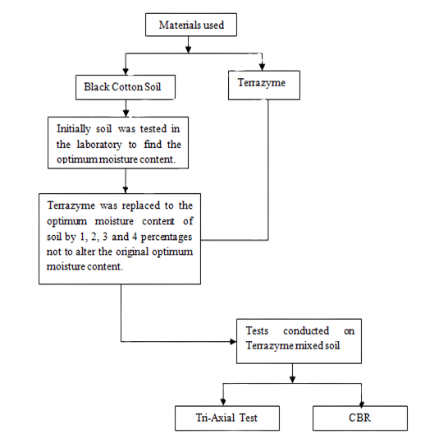

Chart-3.1: How terrazyme is reacting with black cotton soil

Terrazyme is a commercial soil conditioner and microbial product that is claimed to improve soil health and fertility. To evaluate its effect on the basic properties of soil, you can conduct a scientific experiment or field trial. Here is a basic outline of the steps you can follow:

**1.Hypothesis:** Start by formulating a clear hypothesis that states the expected effect of Terrazyme on the basic properties of the soil. For example, your hypothesis might be, "Terrazyme will improve soil structure and nutrient content."

**2. Experimental Design:**

**a. Control Group:** Select a control group of soil that is untreated and represents the current condition of the soil.

**b. Treatment Group:** Select a treatment group of soil that will receive Terrazyme according to the manufacturer's recommendations.

**c. Replicates:** Ensure you have multiple replicates of both the control and treatment groups to account for variability.

**3. Baseline Testing:**

**a. Initial Soil Analysis:** Before applying Terrazyme, conduct a comprehensive analysis of the baseline soil properties. This may include pH, organic matter content, nutrient levels (NPK), soil texture, and other relevant factors.

**b. Record Data:** Record the initial data for both the control and treatment groups.

**4. Application of Terrazyme:**

a. Apply Terrazyme to the treatment group following the manufacturer's instructions.

**5. Monitoring:**

a. Over a specified time period (e.g., several weeks or months), monitor the soil properties in both the control and treatment groups. You may want to track changes in pH, nutrient levels, microbial activity, soil structure, and any other relevant parameters.

b. Regularly record data to quantify any changes or improvements.

**6. Data Analysis:**

a. After the monitoring period, analyze the data collected for both the control and treatment groups.

b. Use statistical methods to determine if there are significant differences between the two groups. You can use t-tests, ANOVA, or other appropriate statistical tests.

**7. Conclusions:**

a. Draw conclusions based on the data analysis. Determine whether Terrazyme had a significant effect on the basic properties of the soil, and if so, describe the nature and magnitude of these effects.

**8. Discussion and Reporting:**

a. Discuss the implications of your findings and their relevance for soil management and agriculture.

b. Write a report summarizing your experiment, including the methods, results, and conclusions. Share your findings with relevant stakeholders, such as farmers, agricultural extension services, or researchers.

**9. Peer Review:**

a. Consider having your research reviewed by peers or experts in the field to ensure the validity and reliability of your findings.

**10. Future Research:**

a. If Terrazyme appears to have positive effects on soil properties, consider further research to understand the mechanisms involved and optimize its application.

Remember to conduct your experiment in a controlled and systematic manner, and consider factors such as environmental conditions, soil type, and other variables that might affect the results.

Moisture content

Compaction test

Moisture content

**3.2 Objective-2:** To determine the engineering properties of black cotton soil.

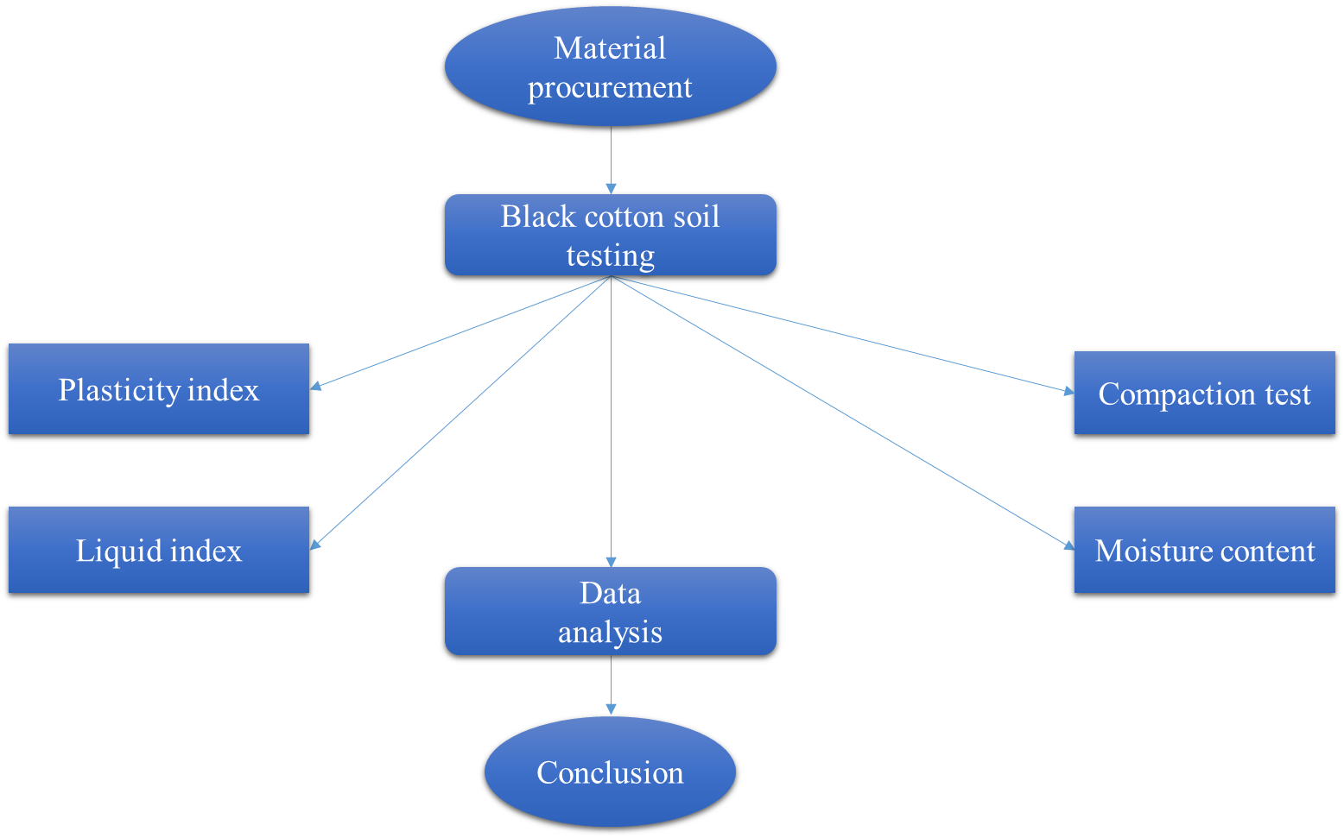

Chart-3.2: Test on properties of black cotton soil

Black cotton soil, also known as Regur or Vertisols, is a type of soil found in certain regions, particularly in India. To determine the engineering properties of black cotton soil, you can conduct a series of tests and investigations. These engineering properties are crucial for various construction and civil engineering projects. Here are some common tests and procedures:

**1. Visual Inspection:**

Start with a visual inspection of the soil. Observe its color, texture, and any visible features like cracks or swells.

**2. Sample Collection:**

Collect undisturbed and disturbed soil samples from the site. Undisturbed samples are preferred for certain tests.

**3. Moisture Content:**

Determine the moisture content of the soil sample. This is typically done by weighing the sample before and after drying it in an oven. Moisture content affects the soil's volume and strength properties.

**4. Grain Size Analysis:**

Conduct a grain size analysis to determine the soil's particle size distribution. This is important for classifying the soil and assessing its engineering properties.

**5. Atterberg Limits:**

Perform Atterberg limit tests to determine the plastic and liquid limits of the soil. This information helps classify the soil as either cohesive or non-cohesive and is essential for construction design.

**6. Specific Gravity:**

Determine the specific gravity of the soil particles. This is important for calculating the void ratio and porosity of the soil.

**7. Compaction Test:**

Conduct standard Proctor or modified Proctor compaction tests to evaluate the soil's compaction characteristics. This helps in determining the optimum moisture content and maximum dry density for compaction.

**8. Consolidation Test:**

Perform consolidation tests to assess the soil's settlement characteristics under load. This is essential for foundation design.

**9. Permeability Test:**

Determine the permeability of the soil using tests like constant head or falling head permeability tests. This is important for assessing drainage and seepage characteristics.

**10. Shear Strength Tests:**

Conduct shear strength tests, such as direct shear, triaxial, or unconfined compression tests, to evaluate the soil's strength properties. This is crucial for slope stability analysis and foundation design.

**11. California Bearing Ratio (CBR):**

Perform CBR tests to determine the soil's load-bearing capacity. This is important for road and pavement design.

**12. Swelling and Shrinkage Characteristics:**

Investigate the soil's swelling and shrinkage properties, as black cotton soil is known to expand and shrink significantly with changes in moisture content.

**13. Chemical Analysis:**

Conduct chemical analysis to check for the presence of sulfates and other chemicals that might affect the soil's properties.

**14. Reporting and Analysis:**

Document the results of all tests and analyses. Provide recommendations and conclusions regarding the soil's engineering properties and its suitability for specific construction purpose.

It's essential to follow standard testing procedures and ensure that the tests are carried out by qualified personnel. The results of these tests will help engineers and geotechnical experts make informed decisions regarding construction and foundation design in areas with black cotton soil.

**3.3 Objective-3** To determine the effects of adding terrazyme to black cotton soil on its properties by conducting various laboratory tests.

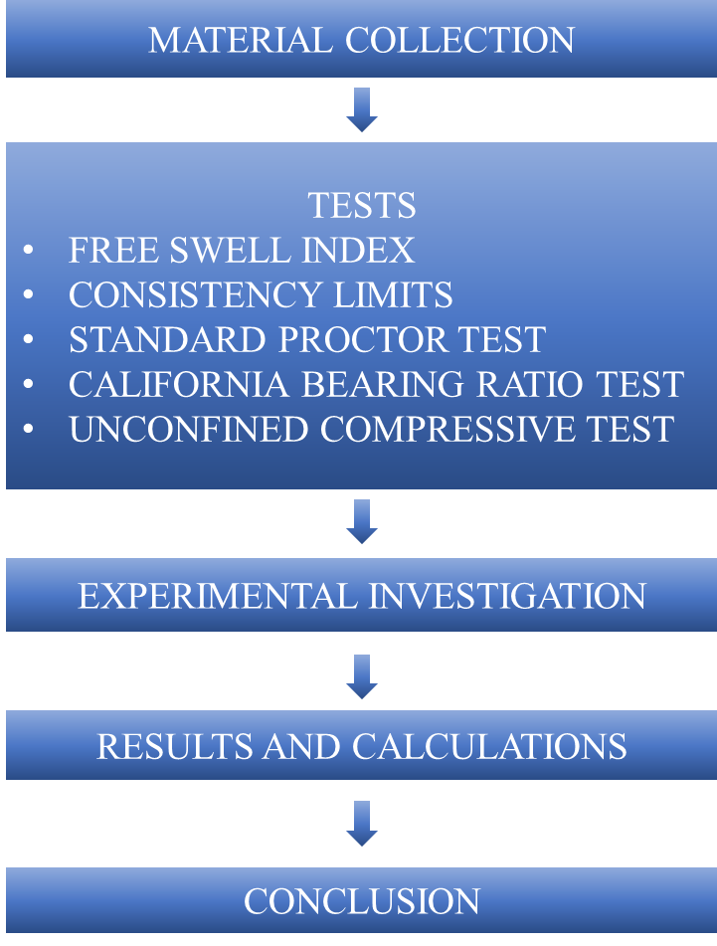

Chart-3.3: Tests conducting on samples

To determine the effects of adding Terrazyme to black cotton soil on its properties, you can conduct a series of laboratory tests before and after the application of Terrazyme. This will help you assess the changes in soil properties and understand how the soil is affected by this soil conditioner. Here's a step-by-step procedure:

**Before Applying Terrazyme:**

**1. Sample Collection:**

Collect undisturbed soil samples from the area of interest. Ensure that you take samples from multiple locations to account for soil variability.

**2. Baseline Testing:**

Perform a series of laboratory tests on the collected soil samples to determine their initial properties. These tests can include:

* Moisture content
* Grain size analysis
* Atterberg limits (liquid limit, plastic limit, plasticity index)
* Specific gravity
* Compaction tests (Proctor or modified Proctor)
* Shear strength tests (e.g., direct shear, triaxial, unconfined compression)
* Permeability tests
* Swelling and shrinkage tests
* California Bearing Ratio (CBR) tests
* Chemical analysis (if necessary)

**Applying Terrazyme:**

**3. Follow Manufacturer's Recommendations:**

Apply Terrazyme to the soil samples following the manufacturer's recommended dosage and application methods.

**4. Mixing and Curing:**

Mix the Terrazyme thoroughly with the soil samples and allow them to cure for a specified period as per the manufacturer's guidelines.

**After Applying Terrazyme:**

**5. Post-Treatment Testing:**

Conduct the same series of laboratory tests on the treated soil samples to assess changes in their properties. This will include the same tests conducted before treatment, such as moisture content, Atterberg limits, compaction tests, shear strength tests, permeability tests, and CBR tests.

**6. Comparative Analysis**:

Compare the results of the laboratory tests before and after the application of Terrazyme. Pay attention to changes in moisture content, compaction characteristics, shear strength, and other relevant properties.

**7. Data Analysis:**

Analyze the data to determine if there are significant differences in the properties of the treated soil compared to the untreated soil. Statistical methods may be employed to assess the significance of these differences.

**8. Conclusions and Recommendations:**

Draw conclusions based on the data analysis. Determine whether Terrazyme had a significant effect on the properties of the black cotton soil. If so, provide recommendations on the potential applications or benefits of using Terrazyme in soil improvement.

**9. Report and Documentation:**

Compile a detailed report summarizing the laboratory tests, procedures, results, and conclusions. This report can be used to communicate the findings to relevant stakeholders and decision-makers.

**10. Future Research:**

If the results suggest that Terrazyme has a positive impact on black cotton soil, consider further research to understand the mechanisms involved, optimize application methods, and explore its implications for practical applications in agriculture or construction. It's essential to follow standardized testing procedures and ensure that the laboratory tests are conducted accurately and consistently. Additionally, consider the specific requirements and recommendations provided by the Terrazyme manufacturer for the best results.

**CONCLUSION:**

Provide a concise summary of the key findings, focusing on the effects of teerazyme on black cotton soil properties. Discuss the practical implications of the study's findings, especially in the context of construction and infrastructure development in areas with black cotton soil. Acknowledge any limitations of the study and suggest areas for future research to enhance the understanding of teerazyme's potential in soil stabilization. Conclude by reiterating the significance of the study and how the results contribute to the field of soil stabilization, emphasizing the potential application of teerazyme in practical scenarios.

**CHAPTER-4**

**REFERENCES**

1. Vishal Saxena,(2017) “Review paper on soil stabilization by terrazyme journal-IJRET ISSN: 2248-9622, Vol. 7, Issue 4, pp.54-57”.
2. Balakrishna.Y,(2017) “Improving the Properties of Black Cotton Soil Using Terrazyme as an Admixture journal-IJOEAT (ISSN-2395-1303),vol 3,issue 1,p.p 96-105.
3. Dr.Vijaykumar Sharma,(2017) “Effect of bio-enzyme (terrazyme) on the properties of sub grade soil of road journalIJOIRISAE (ISSN-2454-9665) vol 3, issue 3, p.p 231-236.
4. Saurabh B. Gautam,(2016) “Subgrade Soil Stabilization using Terrazyme IJARIIE-ISSN(O)-2395-4396 vol 2, issue 3, p.p 2522-2528.
5. Amithkadabasheshadri, (2016)“Black cotton soil stabilization by bio enzymes journal-AIJRES (ISSN-2455-6300),vol 1,issue 10,p.p 252-265.
6. JoydeepSen ,Jitendra Prasad Singh (2015) Stabilization Of Black Cotton Soil Using Bio-enzyme For a Highway Material journal-IJIRSET(ISSN-2319-8753) vol 4, issue 12, p.p 12453-12459.
7. Venika Saini1, and Priyanka Vaishnava,(2015) “Soil stabilization by using terrazyme journal-IJAET ISSN: 22311963, vol 8,issue 4, p.p 566-573.
8. Vijay Rajoria1, Suneet Kaur, (2014)“A review on stabilization of soil using bio-enzyme journal-IJRET eISSN: 2319-1163 | pISSN: 2321-7308”.vol 3, issue 1,p.p 75-78.
9. IRC: 37-2001, “Guidelines for the Design of flexible pavements”.
10. I.S.:1498-1970, “Classification and Identification of Soil for General Engineering Purposes”.
11. I.S.:2720 (Part 3)-1980, “Determination of Specific Gravity of Soil”.
12. I.S.:2720 (Part 8)-1983, “Determination of Water Content, Dry Density relation of Soil using Heavy Compaction (Second Revision)”.
13. I.S.:2720 (Part 4)-1985, “Specification for Grain Size Analysis”.
14. I.S.:2120 (Part5)-1985, “Determination of Liquid & Plastic limit of Soil”.
15. I.S.:2720 (Part 10)-1973, “Determination of Unconfined Compressive Strength of Soil”.
16. I.S.:2720 (Part 16)-1979, “Laboratory Determination of C.B.R of Soil (First Revision)”.